Initial Mockup:

Member: Dingyuan Xue, Sicen Liu

App: EasyScreen Translator

Figma design link: <https://www.figma.com/design/hHoTxVitCkKzs9VT8ijrri/Untitled?node-id=0-1&node-type=canvas&t=6DkNP8kWwKYufmjN-0>

Figma prototype link: https://www.figma.com/proto/hHoTxVitCkKzs9VT8ijrri/Untitled?node-id=0-1&t=zXuhgxG62eeaFnJr-1

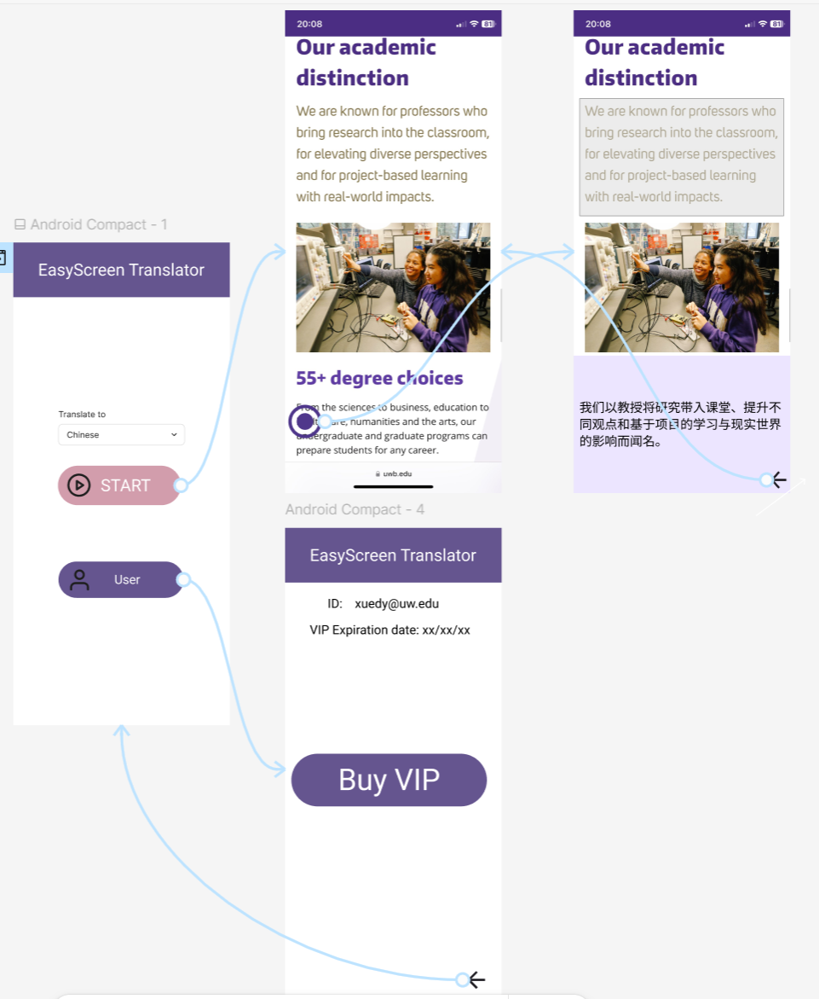

Explanation:

Golden Path: First, users press Start Button to start the service. The app will run in the background and show a floating button on the foreground screen. Second, users can press this floating button to begin translation. Users can choose an area by swiping and the translation will show up in the bottom. Finally, users can press back button  to back the foreground screen.

Target demographic: Students who need to read foreign language articles on mobile devices. The app will run on the background, so that it will not cover the screen which the user is currently reading. Users do not need to copy the content or upload the image and open another translation app. Instead, our app allows users to just press a button to get the translation, which makes it convenient, causing less distribution for users’ reading.

Success criteria:

1. It fully realizes the function. These UI elements contains all necessary functions.
2. It achieves at least an 80% satisfaction rate in user feedback within the first three months.
3. It attains a conversion rate of at least 10% from free trial users to paid subscribers within the first three months. By pressing Buy VIP button  to pay the subscription.